Computer Language Coding Concepts

Private & Public
< Article text >

See also: < List of articles >

Author & Copyright: <Jan-Joost van Zon> Date: <May 21, 2008> – <May 22, 2008> Location: <Oosterhout, The Netherlands> Status: [ Under Construction | Finished | … ]

Ideas
Access control will be fully managed
by the access control module, even for
access controlling an object's members,
making the members only accessible
to the direct container of the member in
order to hide complexity from the outside,
or to to protect data the object's data.

But that form of access control is so
important in programming software,
that it is introduced earlier
as the concept of Public & Private,
before access control is worked out
as a complete solution to security.

-----

Explicit display that something is private
is optional.
Explicit display, that something is public
could be made mandatory, because
is it not overhead in notation: it clearly
indicates a connection point.

-----

Private data can only ever be used
by an object's friend commands.

-----

You will not be able to totally make clear what
private and friend means in this context,
but you can just use the term command anyway,
to make it clear.

Private Names,

It is important to separate the interface from the implementation.
The implementation is only visible in the target definition.

For execution control commands, you have to be able to hide the name of a symbol when you call it. So while the symbol itself can be part of the interface, the name could be part of the implementation, which is not visible unless you’re editing the definition of something.

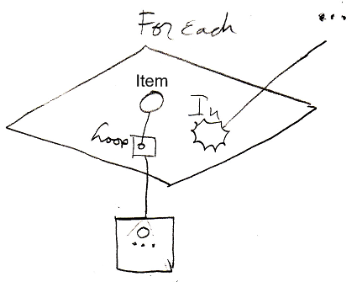
The cirlce inside the loop parameter is not named. It is an unnamed parameter, that might be referenced through the name of the variable it is pointing to. But I’m not sure about that.

JJ

Public and Private,
2008-08-09

I really need an article group explaining a simple approach to Public and Private, that deals with complexity hiding and shows for instance, that private stuff is mostly only visible in a definition, and not in a call or object.

JJ

Public & Private,
2008-08-16

Perhaps for objects, private contents also only need to be created, when one of its friend commands is run.
But this is such an influential implication, that it needs to be covered elsewhere. Privates only make sense, when only a selection of commands, can access those privates.
So only when an object’s friend command is executed, the object’s private contents are needed.
But a sub-object’s system commands can also access privates…

JJ

Public & Private,
2008-08-28

Private may be expressed differently.
The expression I used to have in mind was:

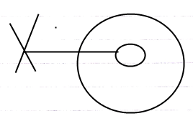

But that looks more like it can’t be a reference, rather than it can’t be referenced.
The latter may be expressed more clearly by:

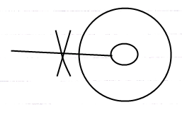

JJ

Private & Public,
2008-06-10

The public members are displayed with
lines going out of the parent object,
with an access symbol attached to it.
The private members have no such
line going out of the parent object.

When a member is accessible as an object,
class or interface, this is a solid line,
when a member is accessible only as a class,
this is a dashed line,
when a member is accessible only as an interface,
this is a dotted line.

Some objects or groups of objects
are friends of the object, meaning
those friend objects can access the private contents
of the object.
You can have friends for reading, writing
or changing (add and delete symbols.)

Next to public, private and who has access to it,
who can access the public and private contents.

If you have friend access to private contents,
you see it as though it was public contents.
This is different from access to private contents
only when editing the definition.

It's the difference between friend for reference,
and friend for change.

If you are a friend for change (not for reference) for private contents,
you will only see the private contents if you are at logical target the definition.

Something needs to be done with protected.

Being able to reference, being able to set reference
is a different thing,
being able to reference as a class or being able
to the class of an object is a different thing?
Do those each get special notations in the diagram?

A user is also an object, that has private content,
that it can make public.

Every form of grant to access is given to an
object in the form of a virtual access card or ticket.
Tickets expire sooner than access cards.
The tickets and access cards form the access control
descriptor for what is accessible to an object.

An object describes what kind of options you have to
have on your card or ticket in order to get access.

Objects have their own security relations.
A user-object is an object with
certain access, but sees the objects' restrictions
to eachother. What's that about? How does that work?

JJ

A command’s access to a parameter’s privates or only its publics.

Expression of access to privates (out of the old document Commands & Classes Loosely Coupled)
(May 18, 2008 )
In the diagrams of Relations Between Commands & Objects you can see, that a call to a command can be a call upon multiple objects to execute that command. It is not yet discussed, how it is expressed that a command has access to the private contents of a class.

> 2008-09-06 A command’s access to privates of an object will be implemented as a command’s becoming a Friend of the class object.
Any friend of another object, is able to access the privates of that friend. This will be the basic rule for Friend access in the article group Private & Public.

Access to the private contents of a class creates a tighter bond between a command and a class. This concept is important. However, the expression of it is not important for now. That will be explained in a different article. The diagrams in this article are merely there for clarafication of the concept and this article is not made to explain diagram expression itself.

Public & Private,
Friend Access,
20008-09-22

In the new computer language’s implementation of parameters, commands only become part of a class if the class is used for one of the parameters of the command.
This makes it possible for a command to become part of multiple classes.
This is a richer and more dynamic approach, than object oriented programming languages. You may now think you are loosing control over the system, if a class gets so easily extended with more commands. But you still have control, as will be explained in the Interfaces article group.
There is one thing however, that’s missing from the story. In C++ and other object oriented programming language, there was one parameter of a global method, that was the this-parameter. The class of the this parameter determined which class the method would be part of. That parameter was the only parameter in the method, whose private contents could be directly acccessed by the method. This is the one thing missing in the story of Parameters: when does a command have access to the private contents of a parameter. The answer lies in Friend-access. A command has access to the private contents of a class, when the class declares its command to be Friend. When a related object is declared Friend, then the related object can access the private contents of the one that declared it Friend.

Commands do not decide on their own whether they have access to a class’s private contents. A class grants a command access to its private contents.

This makes the command more part of the class, but a command is still a separate entity, that can apply to multiple classes.

Private members of a class are useless, unless there are commands that use these private contents. So the informal connection between classes and the commands, that is established by the class’s granting the command access to its private contents, is very tight, and those commands are actually the protectors of that class’s private contents.

Classes giving commands access to their private contents formally is a form of access control. But informally the commands, that have access to the private contents of a class, are the protectors of that class. The class appoints these protectors. Commands do not decide on their own to become such protectors.

JJ

Public & Private,
2008-09-15

Private means on the inside, Public means from the outside.

JJ

Public & Private,
2008-09-17

So Public does not means that you automatically have Private access as well.

JJ

Private & Public,
2008-10-01

Look in the Parameter articles, because some basic access control explanation is in there, that should be moved to Private & Public and only referenced from the Parameter articles.

JJ

Out of the Original Symbol Documentation

Access Control
<Apart from system aspects, access control is one of the hardest concepts to understand for beginning programmers (Not a good formulation, right?)

System aspects is the hardest concept to understand of Symbol Language. Access control, I think, is the second hardest. Not to experienced programmers, but more to beginning programmers. Especially its usefulness may be a blur to beginning programmers: access control makes you able to limit the possibilities. <>

>

<Access control is niet voor beginnende programmeurs. Het is ongrijpbaar misschien, maar zeker onbruikbaar, omdat ze er niet mee om kunnen gaan.

Wat wel zo is is dat de standaard access control van system procedures er voor zorgt dat je niet zo maar rare dingen kan gaan doen. Erg belangrijk als je effe snel iets programmeerd, dat je de echt rare effecten uitsluit zonder extra moeite.>

< Give a story about the true meaning of an access symbol that denotes direction. That it is a syntactically correct access symbol. Access symbols can used to denote direction, because access symbols can point out direction.>

<< A procedure’s primary access controller is only made Inaccessible to ‘outcomment’ code. This is a rather small concept. The rest of the use of Inaccessible and Accessible is in exclusion. Therefore, I need to denote in short that this is the only use of the primary access controller. I can basically always speak of access modifiers when talking about Accessible and Inaccessible. I can use the term exclusion in a lot of places where I now use ‘access control’. I also need to put the first section ‘Accessible and Inaccessible’ in the exclusion section. >>

<< Exclusion is restriction set by a container. Level restriction is like exclusion set by a child for the container. >>

<< Public and Private are an application of exclusion. So then the base of the explanations can be only accessible and inaccessible.

- Accessible and Inaccessible
  - Diagram notation of those two
- Exclusion (can then already be covered)
  - Private, Public is exclusion
  - Protected
  - Access Modifiers in Globalities needs to be further thought through. It gets tricky as you put it in diagram code.
  - Level Restriction
- Friends
- Access Controllers for System Procedures

< Don’t say that procedures can’t be defined as inaccessible. They have to be definable as inaccessible or you’re not able to ‘comment out’ code. This also requires you to use the term access controllers more often. >

< The word access modification can actually be replaced by ‘exclusion’ in many places, but not everywhere by far >

Introduction
Access to procedures can be limited to certain parties by using access controllers.

Access to procedures is controlled. But access control usually defines which objects get access. In a special case you can control which specific procedures get access.

Usually, access to procedures is controlled in a type and each of its objects adopts those same access settings.

Only procedures get access controllers, not objects. Access to an object is controlled by access controllers of the Target Object procedure.

Exclusion

Accessible and Inaccessible
The two basic access controllers are Accessible and Inaccessible. Their diagram notations are as follows:

  Accessible |   Inaccessible

The meaning of them is as can be expected: the Accessible square is accessible, while the Inaccessible square is inaccessible This basic notation does not show which parties get access and which do not.

The symbols used here are actualy access symbols, which I’ve already introduced. Access symbols can denote direction, and they also denote where access takes place, but they’re also used to denote access control.

Exclusion
< A way to pronounce access modifiers for deeper depths than 1 so access modifiers other than accessible, inaccessible, public or private >

Exclusion is the primary method for controlling which parties get access to a procedure.

A type controls which of its procedures are accessible to the outside (Public procedures), and which are not accessible to the outside (Private procedures). Private procedures are accessible to the inside the type.

Apart from controlling access to the type’s own procedures, a type can also control publicity of procedures of its chilren. That way you can publish a child, but make some of its public procedures inaccessible outside the parent. This way you can also exclude members of a base type. A parent can’t make a child’s procedure inaccessible to the child itself; it’s the child’s own procedures.

You can also exclude members of ancestors even further down the hierarchy.

Forms of exclusion other than Private are just called exclusion or privatising.

You can only make a procedure of a child less accesible, never more accessible. The parent can’t publish a child’s procedure that the child defines as Private. A child can’t put restrictions on how its members are privatised by the parent, so a parent has full control over the exclusion of the procedures its ancestors.

Exclusion access controllers are also called access modifiers, because they modify formerly set access controllers.

Diagram Notation of Exclusion
Public and Private are notated as follows:

  Public |   Private

The reason that the following notation won’t do:

  Not Public |   Not Private

is that this access modifier is imposed by the procedure itself, not by its parent.

The reason that the following notation won’t do:

  Not Public |   Not Private

is that the access symbols in these diagrams are about access to the object, not access to the procedure of the object.

Each descendant that has access to the procedure can impose its own access modifier upon it.

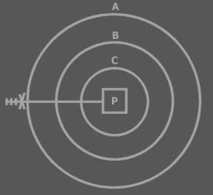

In this example A privatises P. The marks and the access controller are called an access controller list. The whole access controller list can be interpreted as a single symbol, which can be called the access symbol. An access controller can be placed on each mark. Each position in the access controller list represents the access modification of a deeper laid symbol. All access modifications are imposed by A. The first position modifies access to A itself, the second position modifies access to B, the third position modifies access to C, thus the fourth position modifies access to P. The marks are called access marks, not to be confused with the term ‘access symbols’.

Very deep exclusion is uncommon, so you usually won’t interprent more than one or two access marks.

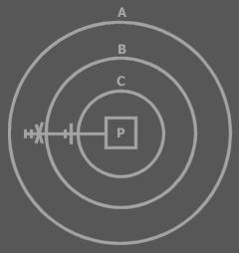

Privatisation is the last access modification. Once an descendant has excluded the member, higher descendants can’t exclude the member again, because they can’t access the member.

B has excluded P, so A can’t exclude P again. Both access symbols above are about access to P. The first position of the access controller list is always about access to the symbol that defines the access controller list. Not all positions of the access controller need to be displayed. The last positions can be left out at will. That means that the last access controller doesn’t have to be about the line target, but can be about an intermediate access.

Let’s cover how to interpret the examples I’ve already mentioned.

With these access modifiers, the procedure is making itself accessible or inaccessible.

With these access modifiers, the object is making itself accessible or inaccessible.

This shows the access symbol for Public. The object is making the procedure accessible to the outside.

This shows the access symbol for Private. The object is making the procedure inaccessible to the outside. The procedure is accessible inside the object. You could denote this:



The extra access symbol denotes that the procedure makes itself accessible. The access symbol of the object makes the procedure inaccessible to the outside. Procedures are usually accessible to the object symbol they are directly contained in, so the extra access symbol is not really required.

A parent can’t make a child procedure inaccessible to the parent. The effect of this rejected concept is basically identical to giving the child its own abstract type: a derived type that excludes members of its base:

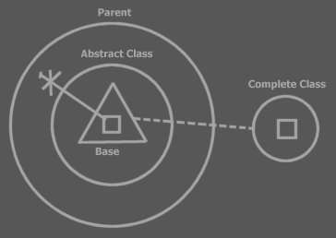

The parent contains a child object. The type of the child is defined right inside the parent: Abstract Type. The type is based on the complete type. The abstract type simply excludes a few members. You don’t always need to show the excluded members. In some views you will only see the published members:

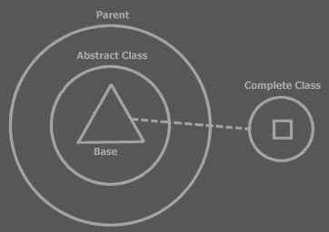

A Procedure’s Set of Access Controllers
Exclusion adds a whole set of access modifiers to a single procedure.

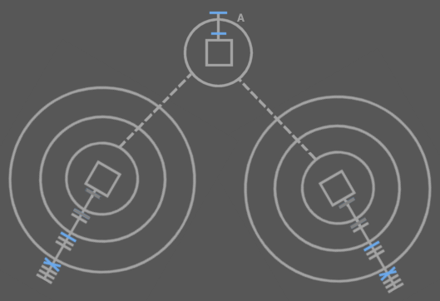

The access symbols in blue are the procedure’s access controllers. The dark grey access symbols are also the procedure’s access controllers, but these were already defined in type A. You can see that in any other type that uses an object of type A, a new set of access modifiers can be imposed. You see that each access controller of the single procedure is shown at a different symbol. The access modifier for a procedure is shown close to the type that imposes the modifier.

Changing Access Modifiers at Run Time
Being able to change access modifiers at run time may be interesting. That way you can for instance change the interface of an object dependent on its settings. Changing a procedure’s access modifier is done by calling the procedure’s Access Modifier Set system procedure. There’s also an Access Modifier Get procedure to obtain the access modifier. This adds two system procedures to a square:

Access Modifier:
Get and Set

The Access Modifier property procedures can be access controlled themselves, so that they can be made inaccessible, for instance when you don’t want to be able to change the access modifier at run time. The access modifiers of the Access Modifier property can’t be changed at run time themselves. In other words: the Access Controller property procedures don’t have an Access Controller property of their own. This complies with the rule: system procedures don’t have system procedures of their own.

A single procedure can have several access modifiers so there are multiple access modifiers to get and set. This would suggest that the Accesss Modifier property has a dimension. However, when you call the Access Modifier property, you return or set the access modifier imposed by the object you’re calling from. The object you’re calling from is a hidden argument to the Access Modifier property. The access modifiers aren’t really stored inside the procedure, but in the object symbol that imposes it.

If the access modifier isn’t variable at run time, then the type defines a fixed access modifier. If the access modifier is variable at run time then the access modifier can be different for each instance of the type.

Inclusion
Apart from a decisive access modifier, you can also give a procedure a suggested access modifier. This means that when you put an object in a type, a procedure of the object will get its suggested access modifier, for instance Private, but if its decisive access controller is Public, then you can still upgrade it to Public. This is called inclusion. The suggested access modifier is always set to less accessible than the decisive one. A type can also give suggested access modifiers to procedures of ancestors.

Exclusion of System Procedures
Exclusion (and inclusion) can also be applied to system procedures. Exclusion is actually very important for system procedures. An object symbol’s Target Object procedure must be accessible to make you able to call its procedures. When you control access to the Target Object procedure, you can for instance set the object to be accessible privately, but not publically.

Exclusion of Set procedures controls who can set a symbol’s lines. Exclusion of Get procedures controls who can get information about lines or who can access the object.

Exclusion of system procedures of procedures also gives parents control over setting call or reference lines and getting information about the lines.

Interesting Applications of Exclusion
So examples of interesting applications of exclusion are:

- Making procedures Public or Private
- Excluding procedures of a public object
- Excluding procedures of a base object
- A parent’s controlling access to objects

Protected
There is another basic access controller in addition to Accessible and Inaccessible: Protected.


Protected
(By the way: it’s not an arrow.)

When a procedure is Protected, it means that it’s inaccessible if contained in a circle, but accessible if contained in a triangle.

 | ≈ | 
 | ≈ | 

A circular descendant automatically privatises a Protected member:

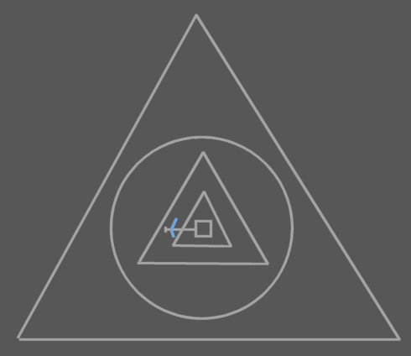 | ≈ | 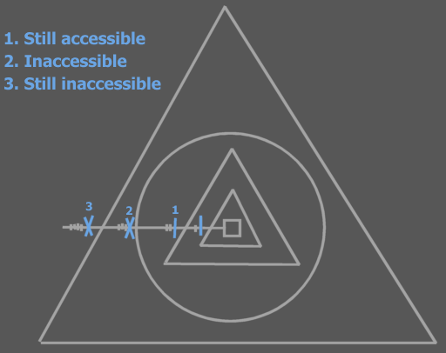

The member isn’t accessible to any higher symbols than the first circular descendant.

Formally the choice of making an extra Protected access controller seems totally arbitrary. In practice there are situations in which it’s useful to work with members that can be accessible to the interface holder, but not accessible to the outside.

Protected is used in exclusion only. It can not be used for ‘outcommenting’ code.

Level Limitation

Object Level Limitation
Basic access controllers are decisive, but level limitation adds additional restriction.

Level limitation is paired with the basic access controller.

Pairing object level limitation with the Public access modifier, makes a procedure public only to limited number of levels up the ancestry.

Public Up 2

A procedure with this access modifier is accessible but two levels up the ancestry. Outside those levels, the procedure is inaccessible.

No object level limitation: Public
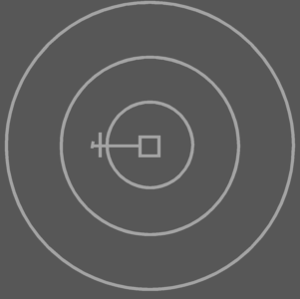 | ≈ | 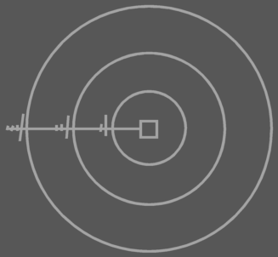
Object Level Limitation: Public Up 2
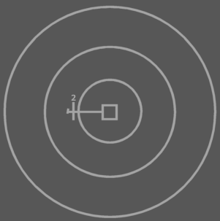 | ≈ | 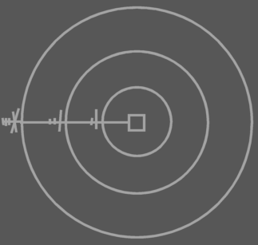

Level limitation works the same for the Protected access modifier, but gets the additional restriction that comes with that access modifier:

Protected Up 2

A procedure with this access modifier is accessible two levels up the ancestry, but inaccessible outside the first circular descendant.

Protected Up 2, contained in three triangles
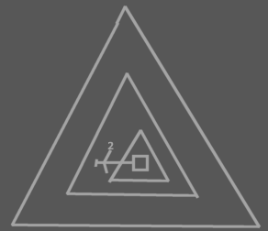 | ≈ | 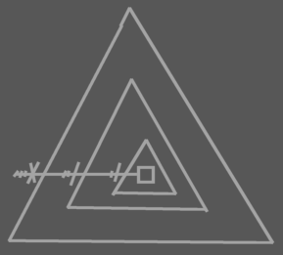
Protected Up 2, contained in a triangle contained in two circles
 | ≈ | 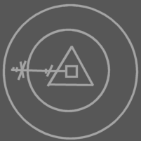
Protected Up 2, contained in three circles
 | ≈ | 

Level limitation can also be applied to deeper exclusion than Public and Protected. So a parent can impose level limitation on a child procedure.

Level limitation on deeper exclusion
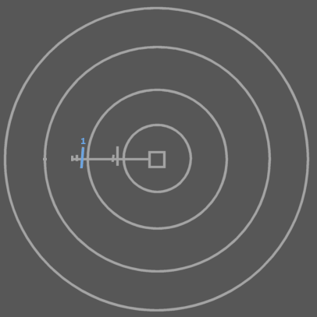 | ≈ | 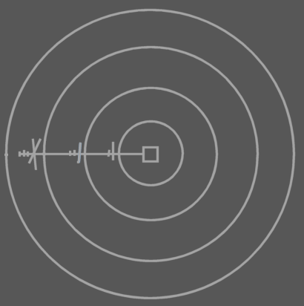

You can also apply level limitation for on symbols shalower than the target procedure.

Level limitation on deeper exclusion
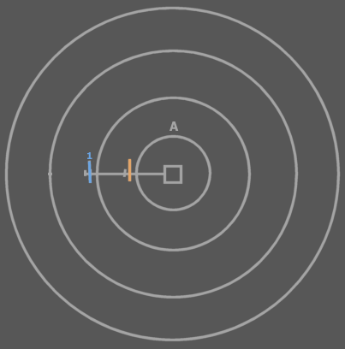 | ≈ | 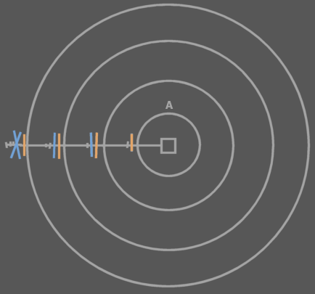

Level limitation is defined there where it doesn’t have effect yet. It only has effect higher in the ancestry. Basic exclusion is always defined there where it has effect. So level limitation automatically excludes members at n levels up the ancestry.

< Figure out a better diagram notation. >

Globality Level Limitation
<Pictures>
Apart from object level limitation there is also globality level limitation.

Public Globality Up 1

When an access modifier is paired with a globality level limitation, the access modifier works normally n level up the globality ancestry. But for higher globalities the member is inaccessible.

Public
 | ≈ | 
Public Globality Up 1
 | ≈ | 
Public Globality Up 2
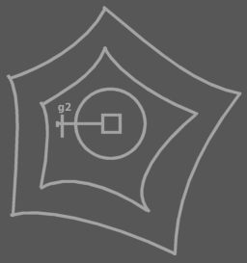 | ≈ | 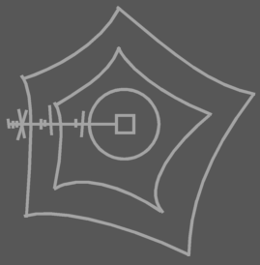

Protected Globality Up N works the same as Public, but adds the extra restriction that comes with protected.

<Pictures with that? >

<‘Globality Up 2’ is too long, because Public Globality Up 1 will be used commonly. Visual Basic’s Friend access modifier is the same as Public Globality Up 1. I might need to invent a specific term for Public Globality Up 1. I won’t use ‘Friend’, because that would conflict with >

Exclusion in Globalities
Access modifiers in Globalities:

- Global Inaccessible
- Global Private
- Global Public

To understand what happens when procedures inside globalities are given access controllers you need to view the globality as an object, that is referenced from any of its ancestor objects:

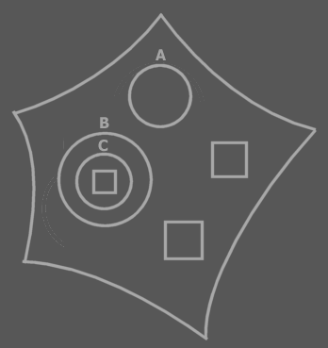 | ≈ | 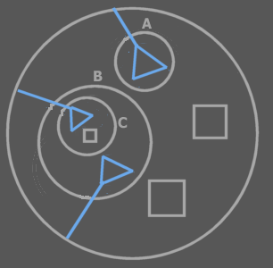

If a global procedure is Inaccessible, it’s just not accessible at all (‘outcommented’), so not really global either. If a global procedure is Private, it’s not really global either, only accessible by the globality object itself, just like something private of a circle object. If a global procedure is Public, then it is global. It is then accessible from any ancestor within the globality.

When a global procedure is Public it is however also accessible outside the globality, as a public procedure of the globality object. For a procedure to be global inside the globality, but not accessible outside the globality you use globality level limitation: Public Globality Up 1.

It is not a permitted to make a global procedure Protected. A pentagon is not exchangable with a triangle, so Global Protected wouldn’t have much meaning.

Friends
In types, globality types, procedures and clauses you can define Friends of the symbol. Friends are other symbols that when defined friend get full access to all members of the befriended.

It only goes one way: the friend symbol can access private things of the befriended, but the befriended doesn’t get access to the friend’s private members. Its kind of a like a sick friendship where one likes the other, but the other doesn’t like him back. That’s why the symbol that defines his friends is called the befriended, not a friend itself.

A type, globality type, procedure or clause can define:

- Friend Types
- Friend Procedures
- Friend Globalities

Which grants its friends full access to the private and protected members of the befriended.

< Diagram notation >

Brainstorm
<<
Om er een (nog) makkelijkere uitleg aan te geven:
Je hebt eigenlijk alleen befriended types. Befriended types geven toegang tot al hun procedures. Als je een friend toegang wilt geven tot maar een selectie van private procedures moet je de friendship bij die specifieke procedures vermelden. >>

Onderscheid tussen befriended procedures en befriended types aangeven.

Exclusion is the primary method for access control. Friends is the method to make exceptions to the privatisation imposed by exclusion. A procedure or type can make any other procedure or type they can reach a Friend, meaning that that procedure or that type has access to all members privately accessible in the befriended.
<… Copy most from the old stuff>

System Procedures with Access Modifiers
<
I don’t have a special notation for publicity of Set procedures.
Set public or not is kind of like read only or not. Maybe I need a read only notation.

Write only is also common, though. For instance of procedure reference input parameters.
>

<Also cover constants>
Access can be controlled for regular procedures this way. You can also control access to system procedures. When you make an object Private, you’re in fact making its Target Object procedure private (which can even get different separate access controllers for Access, Run Time Copy and Design Time Copy).

When you give a system procedure an access controller, access to the procedure or object represented may get a special name and diagram notation.

An object symbol with an accessible State Read procedure, but no State Write, is called a Read Only Object.

An object symbol with only a Type Read, can be considered just a Type. Not an object or interface.

An object symbol with only an Interface Read, can be considered just an Interface. Not an object or type.

…
Etcetera, work it all out

Standaard access controllers
- Standaard zijn Add en Remove geblokkeerd. Zo zijn er nog meer dingen standaard geblokeerd
De klasse kan zelf initial access controllers aannemen die je ook weer kunt veranderen.

Constants (Brainstorm)
<oops the following text can not be put in the introduction>
Design Time Set and Design Time Copy are actually called at run time, because nothing is set at design time. Design Time Set, though, can only be called in the Create procedure of the closest mutual descendant. Actually, a set in the create procedure is actually a call to the Design Time Set and Design Time Copy.

Something is constant if it can be Design Time Set, but not Run Time Set. The initialization of constants happens in the Create procedure of the mutual descendant. < <OR THE one that defines that the set is only for design time?> Explaining that would require knowledge of exclusion.>

Default System Procedure Configuration
< By default everything is public. When studying the access configuration of a symbol you might only want to see what differs from the default >

Access Symbols of Lines, Other Than Call Lines
A line other than a call line can show access symbols, while there aren't really any access. These access symbols represent accesses made by the mutual descendant when it set the line. Accesses did occur on calls to the Set and Copy procedures of the source and target symbols when the line was set.

Access symbols are also used in a diagram only to indicate the access control. In that case there’s no question of an access either. Only of an access that might or might not occur.

Smaller Issues

Access Symbols Represent Accesses
< Just find an appropriate time to mention that each access symbol represents an access, but that it’s also used to denote direction, simply because direction can be read from it >

Grouping Member with Identical Access
<< … yes this is a section >>

Shit. What if you want to group members that are excluded. Then the parent adds a grouping to the child type. Oops this grouping is not part of the child type. Well.. it can’t be used then.

I can use this notation:



Comparison to Other Languages

Visual Basic Friend Members
<< I have to note the application of the Visual Basic Friend access modifier. The basic access controller Friend isn’t required (Public Friend and Protected Friend). Friend Basic Access Controller means that you make a procedure’s own globality a Friend globality.

Yes, but for the effect of the Visual Basic Friend access modifier you also need to deprive global members from being accessed outside the globality. And that is done with globality level restriction.

So the effect of the Visual Basic Friend access controller is replaced by • making the globality a friend of the procedure and level restricting global procedures.

NO! It’s just making it Globality Up 1! Nothing Else! Do not use a Friend Globality for specific procedures!
>>

C++ Friend Functions

C++ Friend Types

So Symbol…
Has put all of the language’s access controllers in one system and added extra useful systematics.

Brainstorm
<The standard access modifiers for system procedures of procedures symbols directly inside a procedure symbol are different from procedures directly inside object symbols. For instance, Symbol Get for Reference of a clause is Private by default. Symbol Get for Reference for an object member is Public by default>

<There are also situations in which you want to disallow copying object reference to an argument, but only allow consult of the argument. (that’s access control of system procedures, actually)>

Automatic Changes when Editing Code
When you for instance use triangles to group members of an object, then the access modifiers need to change. When first you accessed something one capsule deep, is accessed two capsules deep when you put a triangle or circle around it. Access modifiers change accordingly when you edit code:

<P: Circle with public procedure >
<P: Trangle put around public procedure, changed access modifier>
<P: Circle with public procedure >
<P: Circle put around public procedure, changed access modifier>

You can’t always just put circles and triangles around everything. You might have to adjust access controllers, which are explained later. <Is that so?>

Brainstorm
A call is by default private.

The access controllers of the procedure’s sub objects determine which purpose they serve. Maybe I should write a section about that in Access Control.

Required and Optional parameters as well as In, Out and Thru need to be rediscussed in Access Control, because it may be so that it is required for you to Object Set a parameter, while the procedure changes the state of the target
object. This is like thru too, but a totally different fashion and there are more ways of throughput.

Oh, optional parameters are initialized and then assigned the caller’s value. Where are those two steps performed.

Maybe it's a good rule to only show access symbols to denote:

- Direction
- Exclusion of a procedure
- Denote explicitly the publicity

If a configuration of any sort is a common one, it might be nice to make something like a typedef so you give the configuration a name of its own, Like if you commonly use ‘Public Up 1 Globality Up 2’, you might want to give it a different name.

Mayve access controllers are a step into the direction of security. Mayve security should be a kind of advanced access control.

Procedure primarily Inaccessible: This seems unuseful: why not just leave the procedure out completely? It could be used a means to temporarily deactivate code.

Access Controller Parts
In one access controller you can use an exclusion access controller, an object level restriction and a globality level restriction:

- Protected Up 1 Globality Up 2

Access controllers as such are not usual, though and if you use them, they’re not very diverse.

Brainstorm
When being a triangle:

Basically you can optionally totally redefine the access for the case when the type is a used as a triangle.
Protected is a form of that.

<When being a globality?>

Using triangles to group members with equal acccess controllers. As with exclusion, the access controller of the triangle limits access again. It won’t make things more accessible.

Initialization
Sometimes you want to give a specific party access to a private procedure. Such a procedure befriends itself with with a specific type or procedure. The friend type or procedure can access anything private or <> otherwise anything marked as friend for that type <>…
Friend Function: a function that uses the befriended type in a way. It gets access to private members or access to a selection of private members especially selected for the function. The befriended type must be able to access the friend function in order to make it friend.
Friend types must also be accessible to the befriended type.

Only types can be befriended. Friends can be both types and separate procedures.

<< So you can choose to give friends access to all private members or, another method, which requires a different syntax, allows you to make a selection of private things public to friends.

I need to cover the notation of access controllers here for system procedures with multiple access controllers, unless I eventually put the Access Controllers chapter before the System Procedures chapter. In that case I have to cover the it in System Procedures.

Old
< Also look at Access Media : Interface Access >
<<
Does genericity control what happens on the call of system procedures or if the call to a system procedure is illegal or not?
>>

<< Introduce more system procedures here:
Type Generic Get
Type Generic Set
Interface Generic Get
Interface Generic Set
Procedure Reference Generic Get
Procedure Reference Generic Set
Here and no earlier
>>
<< is that the same or different from being able to change type at creation or assignment of object reference ?>>

<<
Old:

A symbol’s type or interface can be generic or explicit.

Generic:

- Generic type: a symbol always adopts the type of its object.
- Generic interface: the interface is the default interface of the type

The type of the object may be generic too. The interface of the type might be generic too. <…>

Explicit:

- The type of the symbol is defined and must match with the type of the object
- The interface of the symbol is defined and must be supported by its type

Assignment can occur by two means: explicit assignment and generic assignment.

The type of the assigned object may be generic too. The interface of the assigned type might be generic too. But the tied together symbols change simultaniously.

Explicit:

- Explicit type:
  - When you assign the object:
It must have this type or an exception occurs
  - When you assign the interface:
The type must support the interface or an exception occurs
- Explicit interface:
  - When you assign the type:
The type must support the interface or an exception occurs
  - When you assign the object:
The object must be of a type that supports the interface (?)

You can change whether or not a type or interface is generic. It is a separate aspect of the symbol. Genericity of type doesn’t mean that it’s of type Object or something, because whenever a symbol has an object, it has a specific type: the type of the object. Whether a symbol has a generic type or interface or not can be set as runtime. Except when the type has been made constant on that part: always a generic interface or always an explicit interface, always a generic type or always an explicit type. Always an explicit type does not mean that the type is constant. The type just always needs to be assigned explicitly, but can vary.

>>

If a symbol already has a type line it has to have that type. If it doesn’t have a type line then it gets the type of the object it’s pointing at (not considering the interface problem below)

Interface <>
Something like this should be possible:

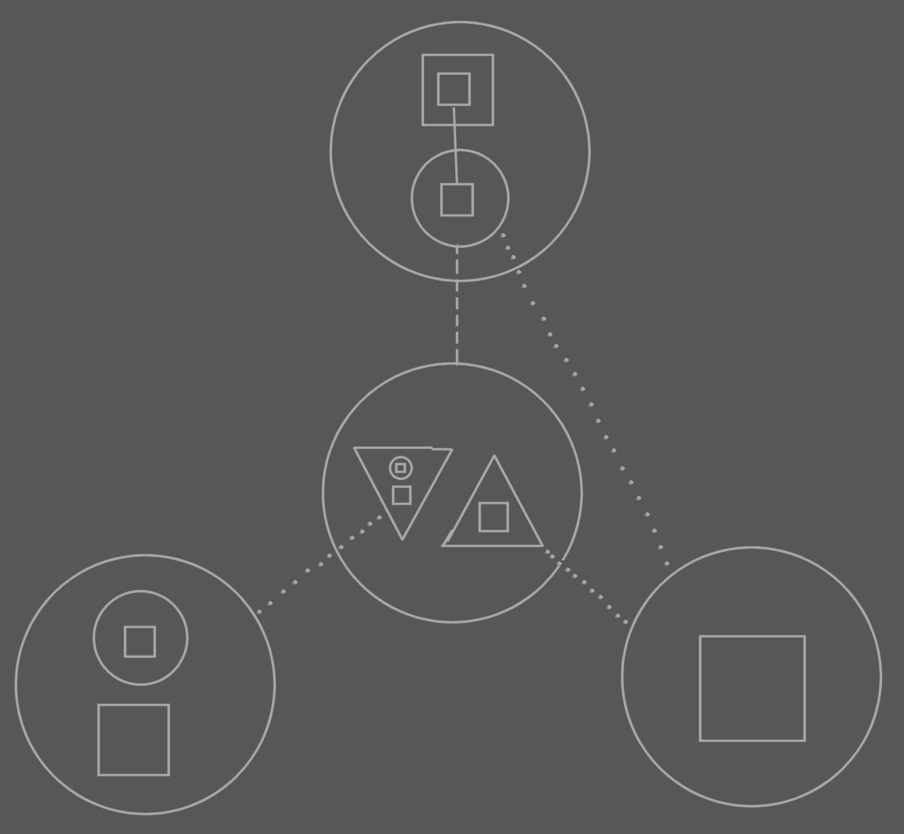

The point is in the lines of the child of the top symbol. It’s type line points to the center symbol, but it’s interface line points to the interface of ONE of its types interface implementations, not to the joint interface implementation of the type. You have to be able to do this.

But it goes against rules I set up earlier. So there has to be more flexibility with interfaces.
The type line no longer determines the interface line.

Ah, more rules need to be invented for working with interfaces.

The type line is pointing at the center circle, but implicitly points at one of the right triangle. So there’s an invisible extension to the type line. The extension changes with the interface line of the source symbol. However… the interface of the child determines which interface is implicitly pointed at by the type line. This seems an explicit/implicit subject.

Another direction rule can be added I guess, looking at the implicit piece of the type line: Sooner to exit from a circle as line source than to exit from a triangle as the line source. <that rule needs some reformulating, though.>

The rule about the type line determines the interface line stays. It’s just that there’s an implicit extension to the type line, which can be generic, pointing at the interface that is the interface of the child…

Type
If you redirect with an object line then the object reference gets the same type as the target object (except when you use a different interface, the previous problem I introduced). Not all the symbols will get a line to the type, though.

Operators

Type Generic Get: | ~::
Type Generic Set: | ~:: =
Interface Generic Get: | ~:
Interface Generic Set: | ~: =

<< Maybe I’ll do special operator symbols in text code that represent the object relations. Actually, that’s what I’d like a little. Except member access. I wanna keep that. >>

Exchangable Object and Procedure Notation

Access in Object Representation
In the object representation, You don’t see that you’re calling a system procedure when you call an Access or Get procedure. In the diagram that looks just like referencing a symbol using an object line, type line or interface line:

<< Picture >>

Access in System Representation
In the system representation you see all access to an object as a call to one of its system procedures.

<< Picture >>

And here I draw out both representations on top of eachother, one representation in one color and the other representation in another color.

<< Picture >>

Other

1
<< The exchangability of method and object notation >>
<< You CAN display a method as an object. You’d then display it as its return value(s) >>

2
You can view a procedure as the object that it returns.

< Picture: Procedure with some private contents and one public object with some contents >

=

< Picture: Object returned >

Actually, the objects symbols I’ve introduced before are the object representation of procedures. They are representations of procedures that return objects.

Here you see that you have multiple representations of something: you can see the system as a bunch of procedures or you can see it as a bunch of objects, but it’s still the same system.

If you regard something a property, which you often will, the primary representatioin of it is its object representation. If you regard something a method or if the procedure doesn’t return a value, then its primary representation is the procedure representation.

3
Conversely, a procedure can apart from it’s usual representation, be represented as the object that it returns.

Procedures
Previous explanations were required before I could go into the more advanced topics about procedures.

Brainstorm
Er moet access control zijn voor het stellen van lines, bijvoorbeeld naar de inhoud van een parent.

- Inside directly accessible, outside only 'indirectly' accessible (if line set FOR you)

Brainstorm
Little disclaimer: I use the word Friend here, but it’s not the same as the Friend access controller. It’s a keyword overused here. However, it’s overused the same way in C++ and I have not yet come up with a decent alternative. The word Friend has been taken over from C++, just like the other access controller keywords. The access controller keywords aren’t super accurate description of their effect, they are just picked because the words are short and you can related their meaning remotely to their effect. I ain’t good at coming up with inaccurate names for something, so I can’t find an alternative now for this second hand use of the keyword Friend. I could go look for more concise words for the access controllers, but those would confuse me, because I’m still used to the old words. And it’s hard enough trying to get the description of this programming language on paper as it is.

Continguous dissector < | Friend for reference

A triangular mark:



Is used to indicate that a symbol that owns the line is Protected, meaning, that it is only accessible when the symbol that owns the line is a triangle. A triangular mark is not an arrow.

Friend for reference
Means access only anywhere within the globality, but not inside embedded globalities.
< 2008-10-10 That was the VB meaning of Friend. >

Procedures Parameters
A procedure can contain variable objects. The public ones are parameters. The friend ones are parameters within the current globality

< Old VB meaning of Friend >

